Visualising database content   
using metadata

# 

# **Intro**

## **Title Page**

A visualisation tool for online databases using metadata to give the user control of the algorithms that filter the content they consume.

## **Statement of Authenticity.**

The author is the bomb and wrote all of the non-cited material

## Abstract:

My research project explores ways in which metadata can be used to present and navigate content in online databases.

It builds on the work of digital artists and interactive documentary makers to provide tools for Wordpress site owners that make use of metadata to create novel ways of presenting their library of images to the users who visit their website or blog.

Metadata forms the basis of an economy that mines the usage data generated as we humans navigate cyberspace. Its central role in this economy dominates our understanding of what metadata is. Historically, and more relevantly for this project, metadata is also the set of descriptors forming the basis of any information catalogue designed to facilitate searching and authentication.

Library catalogues and nomenclature systems such as Dublin Core require categorisation experts to invest significant amounts of time in appropriately categorising information to maximise the usefulness of the metadata stored in these systems. This effort has been the main obstacle in the development of proposed metadata based categorisation systems such as the Semantic Web, proposed by web founder Tim Berners Lee in 2000.

An initial literature survey of the field revealed that despite the vast field of academic research into the Semantic Web there are very few end-user applications and almost no interfaces that have been developed for it. Some rapid prototyping of potential navigation tools for WordPress sites using the existing metadata was undertaken to test the overall theory. As a second stage these separate visualisations were integrated into an overall framework designed to provide a structured path for future development.

The lessons learned from those rapid prototypes indicate that there is a large amount of work to do to create a minimum viable product that might initiate and inspire wide spread use and an expansion of the key principle that visual navigation of metadata might provide context and meaning.

Thus the final project focuses on providing a subset of the initial brief. It is complete but not comprehensive tool for visualising the images within a WordPress site using a number of different visual interfaces that rely exclusively on metadata. Three of four interfaces mimic the work of other visual artists, who employed metadata navigation techniques without developing an overarching theory about the role of metadata in new approaches to visualisation. One interface is an original approach to combining images in interactive media.

As a result of the reduced scope of the practical work, a significant portion of this exegesis is devoted to outlining that underlying thesis and connecting the work of these artists to that underlying theory.

## Acknowledgement

Lecturers, artists, Semantic Web researchers, mentors

## Table of Contents.

**Intro** **2**

Title Page 2

Statement of Authenticity. 2

Abstract: 2

Acknowledgement 3

Table of Contents. 3

INTRODUCTION 5

**Key Concepts** **6**

Metadata: navigation and visualisation 6

The Whale Hunt 8

Prison Valley 9

Examples of visualisation based on metadata 10

D3 JS 11

Voyant 12

Indieweb, SemanticWeb, dbPedia 12

The WordPress ecosystem 13

Existing visualisation and metadata generation tools for WordPress 13

Plugins, themes and front ends 13

Wordpress development 14

**The work** **15**

Components 15

PresentWP 15

Lifejacket 16

The toys 16

**How it was built** **16**

Guide to the documentation 17

**Future directions** **17**

The Wordpress ecosystem 17

Beyond WordPress 18

Beyond the Web 18

Verifiable, meaningful content 18

**Conclusion** **18**

## INTRODUCTION

I started out this project researching the state of the art in **using metadata to organise and find content on the web.** It was my intention to build on work I had done in the eighties and the nineties building bridges between structured and non-structured data by extracting and organising the metadata about content, rather than attempting to structure the content itself.

I had worked with n-dimensional matrices as used in the Australian Census and tagged databases such as Pick (used by IBM in the operating system of the S38 aka Silverlake) and The Corporate Retriever (a Queensland product developed in the late 80s). I carried out research for Sean Howard of Oz-eMail in the early nineties that led to the development of Isys, a text-search engine used by legal firms and government policy bodies. This predated and was then subsumed by the text search engines of the World Wide Web and which introduced the public to text searching as the standard way of grappling with large data sets.

From 1993 - 2000 I built web applications: connecting the web to databases; pioneering content management systems; and developing a metadata index that could be distributed across websites. My plan was to use this project to bring that previous work into the visual, streamed environment of the Web 2.0 by developing a visual interface for navigating that metadata.

My research in early 2018 identified that Tim Berners Lee, founder of the World Wide Web, had initiated a major project called the Semantic Web in 2000 designed to harness metadata and provide a mechanism for searching the web meaningfully and in context. The Semantic Web has attracted thousands of academic researchers but resulted in very few commercial products. Most importantly, the vast majority of the work was focused on the APIs, query language and communication protocols and I discovered very little work that focused on the interface.

I also found a range of digital artists and interactive web documentary makers using metadata as a means of navigating content and mimicked them to develop some quick prototypes with a view to seeing if they might be applicable to the Semantic Web project. I quickly realised that I needed to vastly narrow the scope to complete the research within the available time frame.

This exegesis, therefore, describes a creative tool designed to allow WordPress bloggers to present their visual images in novel and interesting ways. The methods of presenting the content are referred to as visualisations, and the visualisations are enabled by and delivered on a consistent platform that is provided as a WordPress plug in called PresentWP.

In the second half of 2018, as the project was being refined and tightened up, Google and Samsung released automated tools for their image libraries to create collages, stories and animations. These tools significantly overlap with the functionality of PresentWP, undermining its claim to originality and innovation while, at the same, time verifying the validity of its intent. It is too late in the project to find alternative approaches and so the emergence of these tools is simply noted as part of the external environment in which this development has taken place.

# **Key Concepts**

## **Geoff in this section I think you need to first introduce it, saying what you are going to look at and why this is important to your project. Otherwise the reader has to do a lot of work trying to work out why you are covering what you are, and why you care about it. [I’ve highlight the parts of your text, in pink, that point to some of this]**

## **Metadata: navigation and visualisation**

Metadata is important. The fact that there is a metadata economy presents striking evidence of that.

The value of some types of metadata stems from their usefulness as a means of identifying a relevant subset of content without examining the content itself. It is thus faster and more efficient as a mechanism for searching and navigating content.

A key component of this project is the exploration of possible visualisations of content based on its metadata as a means of enhancing or enabling navigation. That is the basis of schemas such as the Dublin Core a metadata system designed to categorise content for distributed information systems as well as the Semantic Web project established in 2000 by Tim Berners-Lee, the inventor of the World Wide Web, as an Open Source research project to create a metadata based navigation framework for the World Wide Web. Its subsequent failure to materialise as a substantial method of sourcing relevant, verifiable content is a clear example of the gap between the vision of software developers and the products they deliver and the challenges inherent in closing that gap.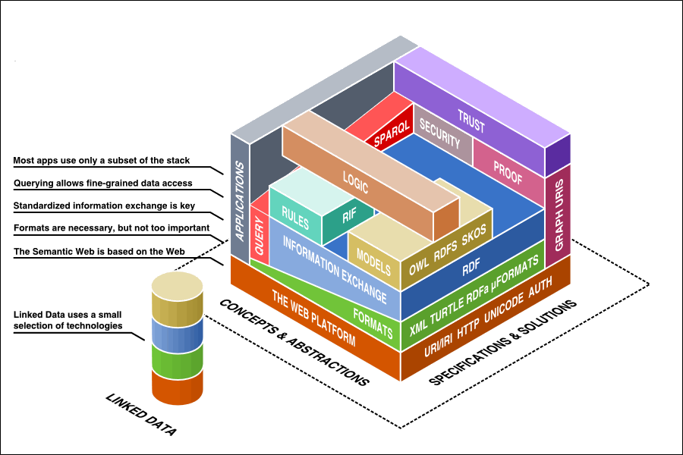

One significant source of value for this type of metadata is to establish the authority and the veracity of sources. By understanding where content is sourced and how it is filtered we can verify, or quantify its reliability and its relevance to a particular enquiry.

A number of commercial tools have been developed based on Semantic Web principles but these are high level corporate tools and have not captured the public imagination. The most commercial of these is Pool Party, available as a corporate tool requiring significant planning and consultation to establish the metadata models required for implementation.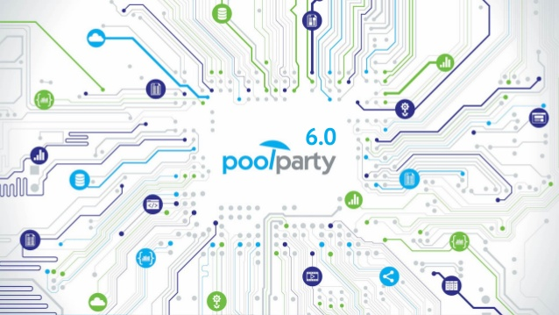

Because of the expertise, concentrated effort and time required to properly categorise data a range of semi-automated tools have emerged to analyse data and generate metadata specifically to enable content analysts to perceive patterns in content which may assist them in their analysis. The Voyant tool-set includes components such as the WordCloud or TagCloud that focus on providing such tools for text content. In contrast, D3.js provides a variety of visualisation tools for visualising data generally. These toolkits and their contemporaries can be described as content analysis tools that generate metadata to assist in the visualisation and analysis of the data itself. 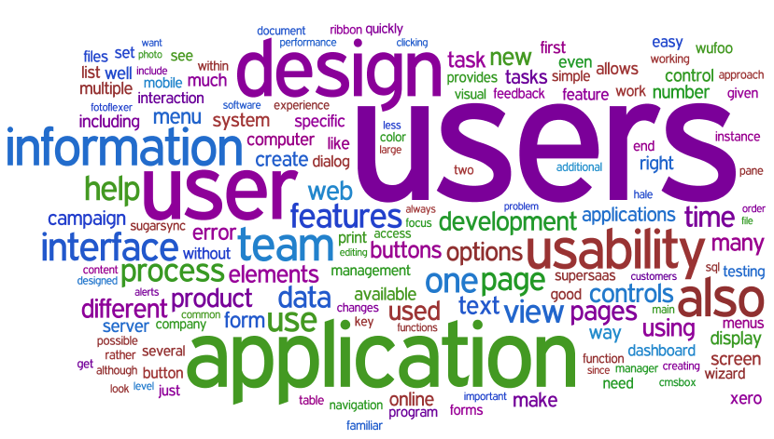

Such approaches are complemented by AI that, for example, analyses images to identify faces and thereby allow the automated creation of links between visual content to create stories in your phone’s gallery or to track people’s movements in CCTV footage for security applications.

Independently, and in contrast to both the manual and automated categorisation approaches, metadata generated by users as we traverse cyberspace has become an incredibly important commercial commodity, often gathered by offering free content and services to attract users for the sole purpose of capturing that metadata. Our phones now use this type of metadata to examine what content interests us, to authenticate us and to determine our physical state.

The field of metadata is therefore growing rapidly, is changing and evolving as it expands and is moving well beyond the bounds of the initial brief of this project. This project specifically deals with the metadata generated by the system to store the content (date, filesize, author), created by the content manager using the content management system (category, tag, visibility) or generated by an algorithm to assist in the extraction of certain subsets of data (hue, aspect ratio, most common words). It then uses that metadata to provide the user with the means of selecting a subset of data to which it can apply one of the selected visualisations.

The tool examined in this exegesis, PresentWP, allows the end-user to create novel and unique visualisations of the content in online databases and thus curate that content themselves. This specific challenge was identified as one potential challenge in the broader field that was able to be addressed within the framework of this Master’s degree. Those constraints and the development path are discussed under The Work, below.

**Art based on metadata**

Having identified that visualisation of online content using metadata was one way to explore this field, a wide range of digital artwork was examined to identify those artworks that use metadata as a primary tool for navigation. [this intro is good!]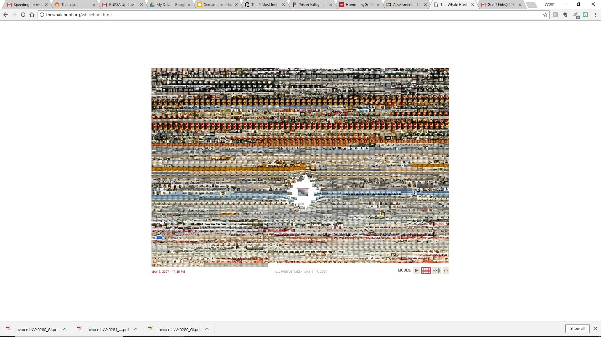

### **The Whale Hunt**

This work is entirely metadata based. It represents nine days spent in an Inupiat community in Barrow Alaska by Brooklyn artist Johnathon Harris in March 2007 (Hennessy 2008). He took a photo automatically every 5 minutes as well as whenever he saw something that interested him. The time of the photo, its hue and the names of the characters in it are the only data used to navigate through the gallery. Of that, only the character identification required curation by the artist, the rest of the metadata is inherent in the system information about the content itself.

The number of photos in any given time period increases in line with his interest in the activity around him. 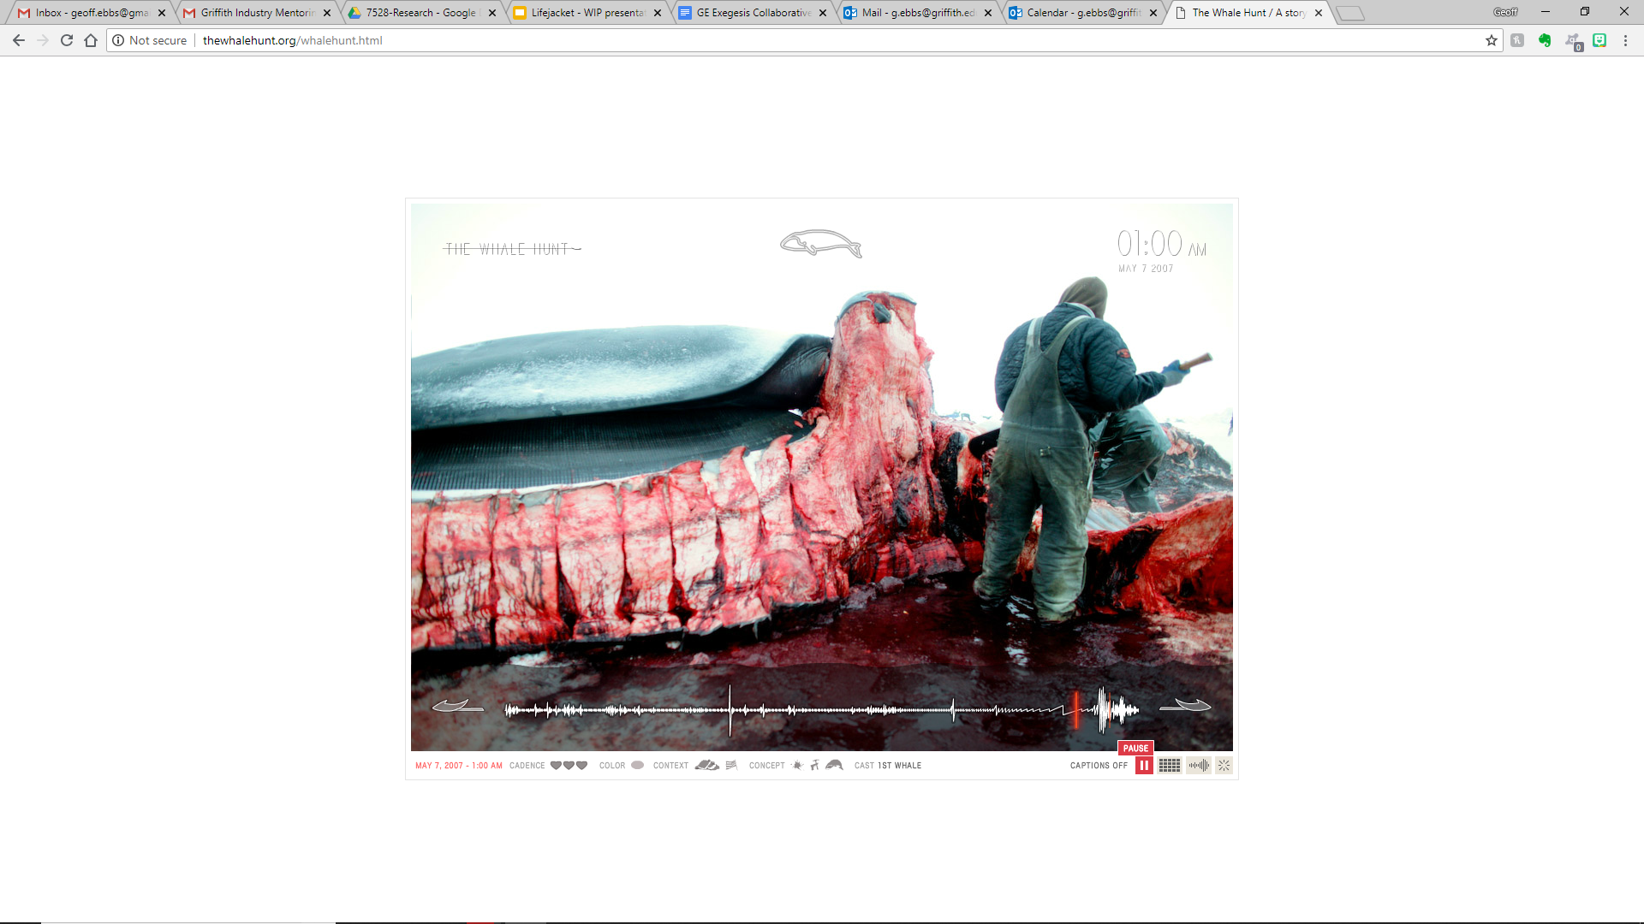

“ In moments of high adrenaline, this photographic heartbeat would quicken (to a maximum rate of 37 pictures in five minutes while the first whale was being cut up), mimicking the changing pace of my own heartbeat.” (Harris, 2007)

Thus the actual account of the whale hunt and, to a significantly lesser extent, his record of getting dressed to go hunting on the Arctic ice represent clearly defined periods of additional activity.

Given the striking and unusual use of metadata as a sole means of navigating a set of photos, this was the first series of visualisations implemented as a “dirty” prototype usable on any WordPress site to test the concept.

### **Prison Valley**

This is a good example of the current state of the art in interactive documentary. Developed by French television studio Arte TV. “ARTE offers high-quality programmes to 70% Europeans in their own language. ARTE programmes are broadcast in [French](http://arte.tv/fr) and [German](http://arte.tv/de) 24 hours a day in HD quality on all screens. … This is a unique experience [cofinanced by the European Union](http://flipbook.arte.tv/ARTE-europe-en) since 2015 "to foster EU integration through culture by providing new subtitled versions of selected TV programmes across Europe". (Arte TV, 2018)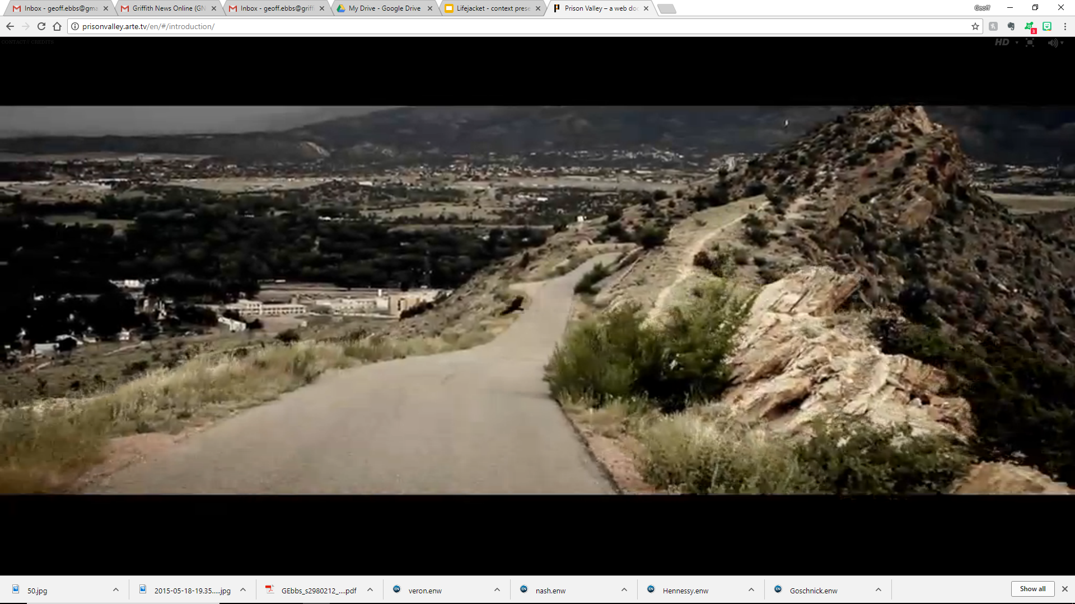

Prison Valley examines an area of the US with 17 different prisons, including the largest high-security prison in the USA. The local economy is totally dependent on the prison economy. The documentary allows the viewer to explore the material gathered by the documentary maker in a variety of ways, using the paradigm of a motel room as the basis of their journey of exploration.

In addition to the editorial curation of the content to provide a narrative there are a number of elements based entirely on the metadata generated by the user as they navigate the content.

The example studied for this project is the use of souvenirs, such as postcards, brochures and tickets, used to identify those areas of content that have been explored by the user.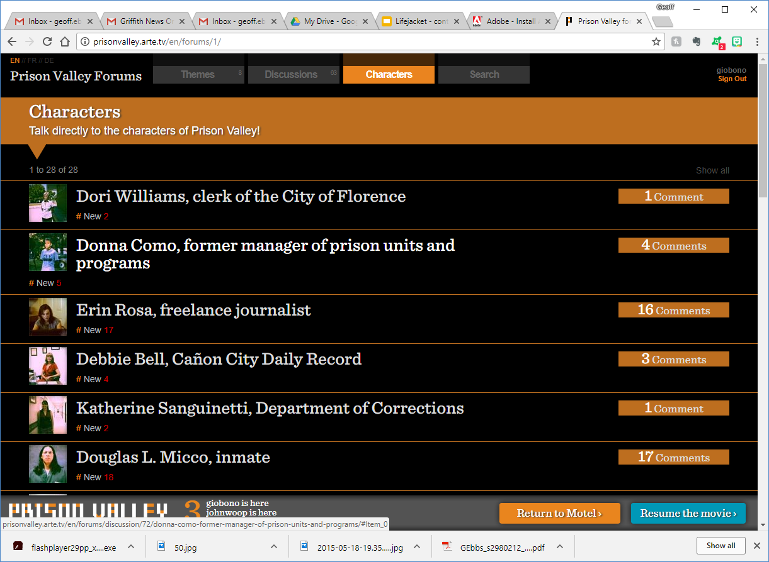

This is an example of user generated metadata (username, date) and system generated metadata (featured image filename, link to content) being captured and employed to enhance the user’s future experience.

## **Examples of visualisation based on metadata**

The British Library exhibition in February 2014 documented ten major uses of data visualisation in human history. One of the interesting things about a number of these visualisations is that the results are important because they are surprising. It was the new knowledge they revealed that makes them significant. In many cases the new knowledge was revealed by detecting patterns in data that was not central to the matter under examination.

For example, the identification of drinking water as a source of cholera in nineteenth century London was determined simply by mapping the address of the deceased against sources of drinking water. The proximity of the deceased to a particular well identified it as a likely source of contamination and thus launched the drive for sanitation that underpins the improved health of humanity to the present day. This is well before the understanding of microbial infection or the work in identifying particular microbes and the vectors that deliver them.

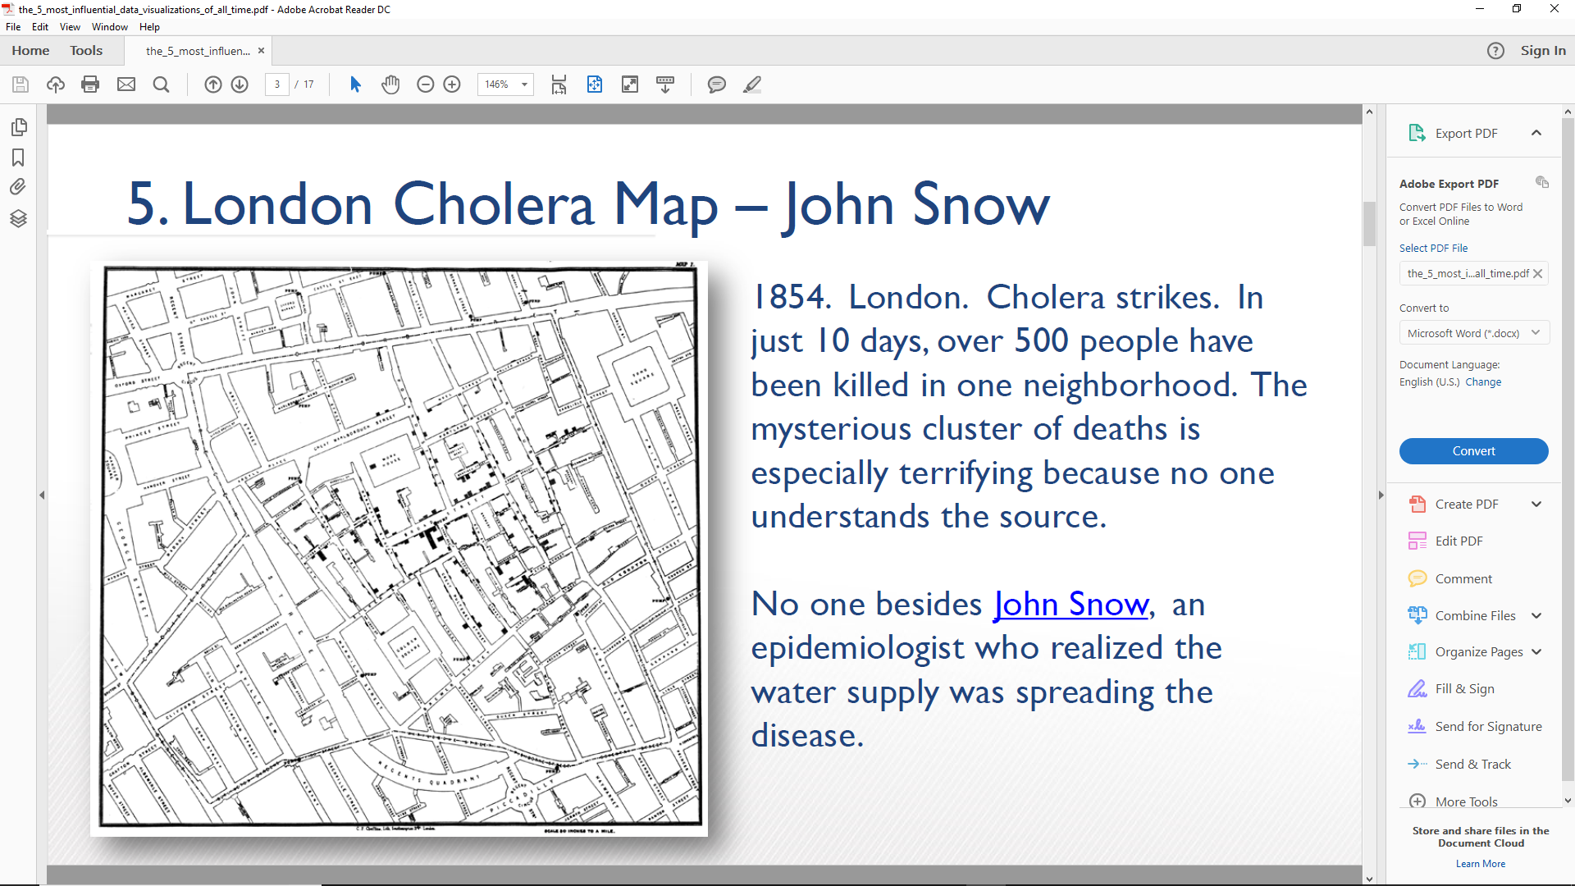Significantly for this project, the address of the deceased is the sole piece of data used to create the visualisation that revealed the connection between cholera and drinking water. That data is peripheral to the illness or the health of the deceased. One may argue about whether the address of the victim is actually metadata as opposed to a different category of data but, for the purposes of this exercise, the important thing as that access to visualisation of data that may be peripheral to the area of content under examination, may reveal patterns that have meaning. In this case, the pattern of addresses revealed proximity to a certain well as a factor in death, identifying the water supply as the source of cholera and so solving a major medical challenge.

### **D3 JS**

This site documents a wide range of visualisation tools that the author has determined as interesting or valuable.

Some of them provide new insights on existing news. Many of them represent news stories of a particular period that use different or remarkable approaches to visually representing the data. The D3 Calendar View is a graphical representation of the movements of share prices on the Dow Jones Industrial Average over 2010 and is an example of this category of visualisation. https://beta.observablehq.com/@mbostock/d3-calendar-view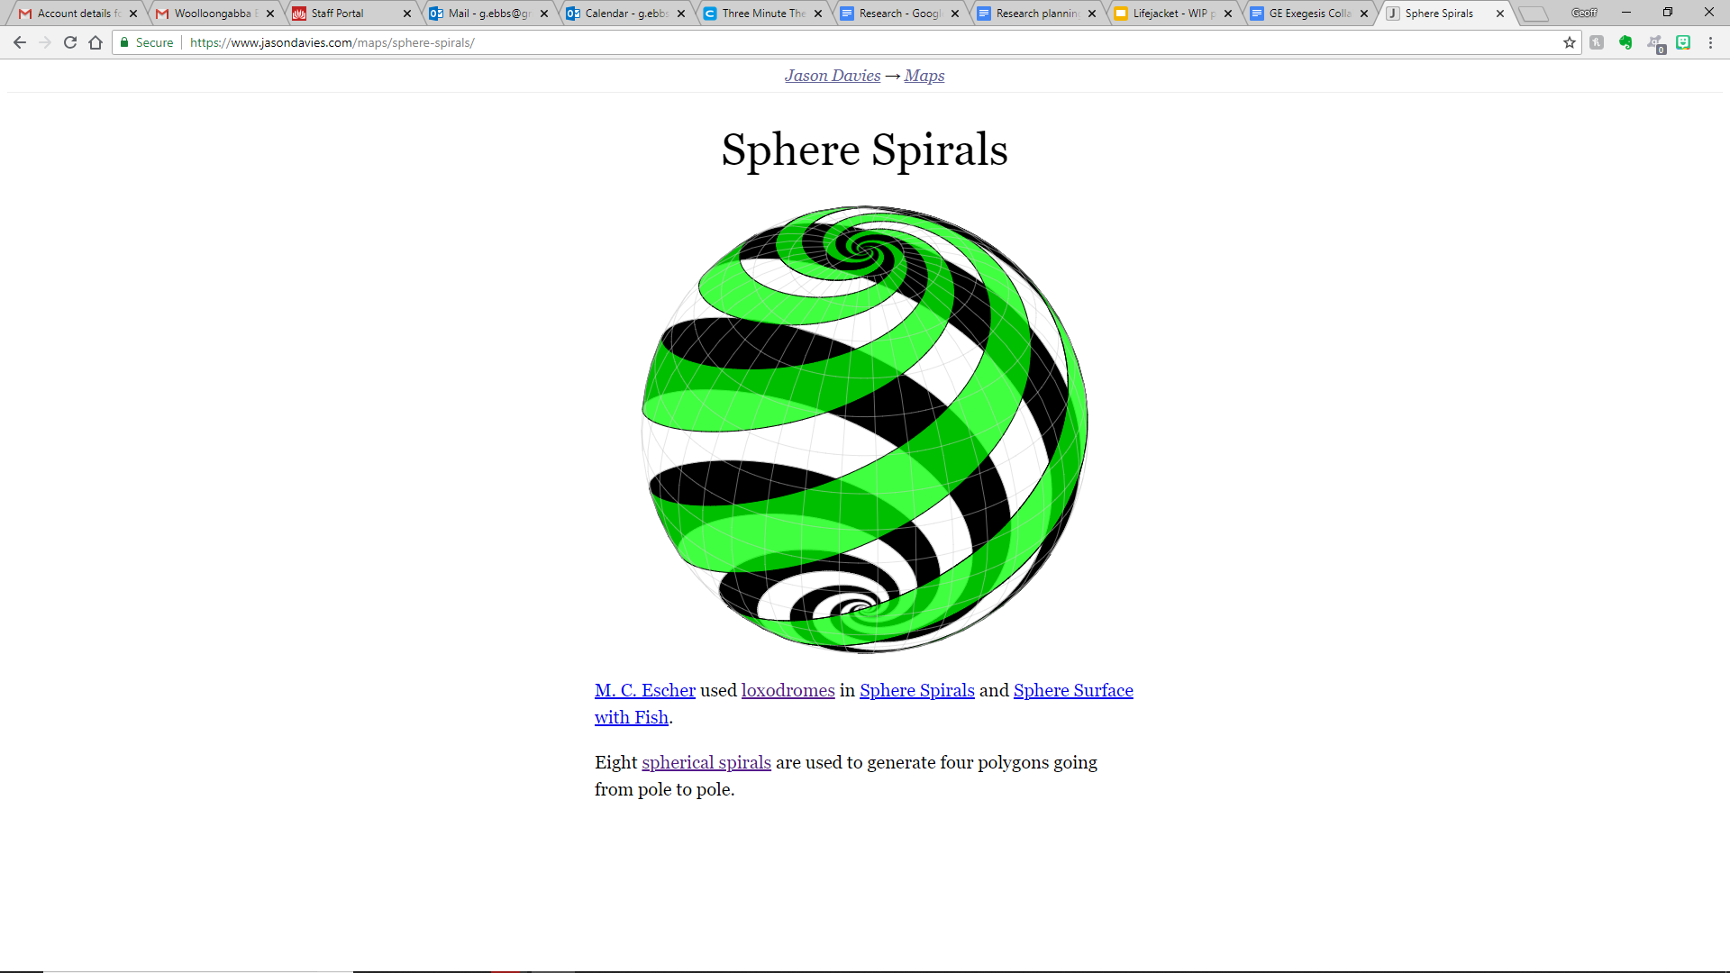

Other items are simply the rendering of mathematical functions in javascript and may or may not have use in displaying data. The spherical spirals for example, is simply a representation of a beautiful form that many of us admire and most of us would not know how to approach. https://www.jasondavies.com/maps/sphere-spirals/

Most importantly for this project, the library is built on a framework known as Observable, offering a method of rapidly developing visualisations using Javascript. It was originally the intention to integrate the Observable framework into the PresentWP framework and facilitate the rapid integration of the library of visualisations already available within D3.JS. The limitations of time available in the Masters project preclude the completion of that. Regardless, the identification of such a library highlights the range of visualisations available, the interest which such visualisations may generate and a forward development path that may have commercial and academic value in the future.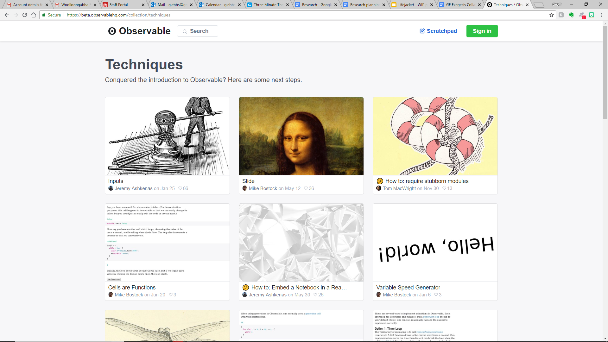

### **Voyant**

The Voyant set of tools voyant-tools.org is described as “a web-based reading and analysis environment for digital texts”. (Voyant, 2018) It is thus a *content* analysis tool rather than a metadex visualisation tool. Because its visualisations are generally based on metadata generated as a result of the analysis of text it falls into the category of “automatically generated categorisation metadata” as outlined above.

At its most basic you can give Voyant a URL and it provides an immediate overview of word frequency overall and by segment. This same approach can be applied to a specific text, or to a pair (or group) of texts for comparison. 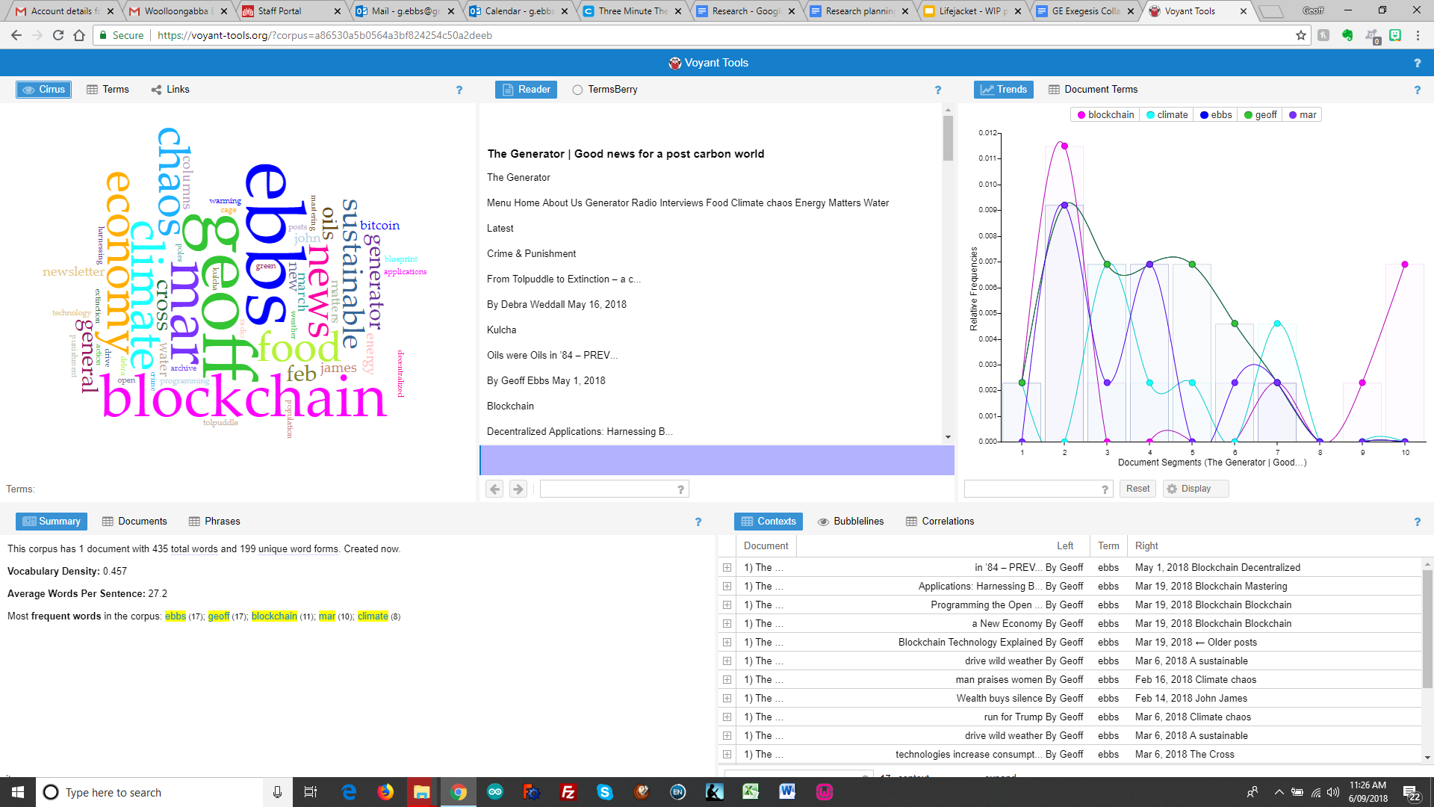

The wide range of visualisation tools makes it useful for a range of purposes. The toolkit itself is “a scholarly project that is designed to facilitate reading and interpretive practices for digital humanities students and scholars as well as for the general public.” (Voyant Tools, 2016) 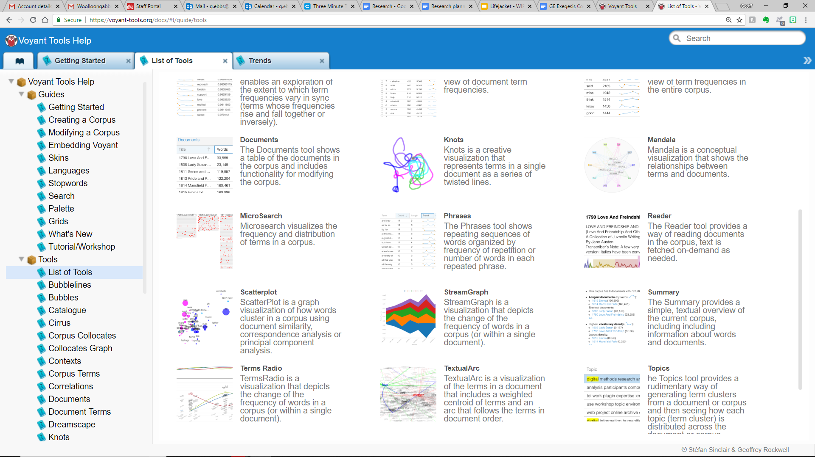

The project is developed as an Open Source project, available on GitHub by Attribution. Similarly to the visualisations presented in D3, it was originally envisaged that the Voyant toolset could be incorporated into the PresentWP framework to strengthen the underpinning objectives of demonstrating the power of metadata as a means of visualising underlying patterns and thereby navigating content. Voyant has a backend Javascript framework called Trombone, which could be used to provide the integration of Voyant visualisations with WordPress. Again, the scale of the work required to achieve that integration is beyond this Masters project and is included here as a potential application of the PresentWP framework and a possible path for future development.

### **Indieweb, SemanticWeb, dbPedia**

Indieweb and a range of other tools that may have long term relevance to this project were lightly researched and not incorporated in the exegesis for time and space reasons. [I don’t understand this section, yet, and what it is for, re indieweb, semantiweb, dbPedia - perhaps this belongs in the ‘key concepts’ seciton?]

## **The WordPress ecosystem**

This section just seems to jump in, out of the blue. Again, some introductory remarks about why you are needing to talk about this, what its relevance is, etc, will be very useful

The decision to use the WordPress content management system as both a source of content and a framework for the delivery of the visualisation was based on both ubiquity and rigour.

With 32% of the URLs on the public web being WordPress sites, it is by far the most popular and widespread content management system in use. That does not make it the source of the majority of content, as many sites (such as newspapers, encyclopaedia, government agencies for example) are much larger than most WordPress sites. Nevertheless, this huge variety of content sources, makes WordPress an attractive environment for exploring and promoting a concept such as Metadex.

In addition to the volume of content, the rigour of the WordPress development environment provides a consistent and accessible source of metadata that is readily able to be mined. While it does not employ the Semantic Web protocols used by specifically Semantic Web friendly sources of information such as dbPedia it is consistently formatted so that it is possible to examine the metadata structures of any WordPress site without the engagement of the owner or a curator.

This underlying structure underwent significant changes in mid-2018 with the introduction of Gutenberg as the content structure paradigm for WordPress. The version of PresentWP delivered with this exegesis predates Gutenberg and is compatible with Wordpress up to 4.9 (the current version at the time of going to press). A development plan for Gutenberg compatibility has been prepared and will be undertaken before any attempt at commercialising the toolkit provided.

### **Existing visualisation and metadata generation tools for WordPress**

Plugins such as InfoGram, Venngage, CM BlogCloud and its siblings generate metadata and visualise it in exactly the way outlined for this project. While they offer specific outcomes to WordPress owners they lack any overarching framework or theory about the extended use of metadata. The ready availability of these tools offers a variety of development paths for expanding the generation and visualisation of metadata within the metadex framework. Conversely, it encouraged the selection of novel representations of visual data as the chosen field of endeavour for this project as a means of differentiation from these existing tools that are no longer novel or fascinating.

### **Plugins, themes and front ends**

The popularity of WordPress means there is a vibrant developer community engaged in development of the WordPress ecosystem. These include people working within the rigorously controlled WordPress environment and those that seek to extend it with one eye on the “next big thing” that may replace WordPress as the major content repository on the web.

This includes layout frameworks such as <check name(s)>, publishing systems <check name(s)> and ecommerce engines such as WooCommerce (WordPress specific) and Magento (CMS independent).

Before defining the value proposition and hence design parameters of PresentWP it is important to examine these existing offerings. While a comprehensive study is beyond the scope of this project, it is important to develop an overview to determine where Metadex is likely to fit.

### **Wordpress development**

At least as important as the third party developers are the tools and frameworks provided and planned by Automattic, the owners and developers of WordPress itself. WordPress.com provides a centralised storehouse of tools and an integrated system for managing WordPress content. Recently the emergence of WordPress search as a tool for searching across participating WordPress sites indicates a vision on the part of Automattic to establish a centralised (or centrally visible) content repository.

Clearly, such ambitions are complementary or competitive to the notion of a cross site tool such as Metadex.

The JetPack toolkit is provided by Automattic to WordPress developers as a means of securing, backing up and analysing WordPress content and constitutes the gateway between each WordPress site and the central WordPress.com services. Again, an examination of the operation of JetPack and its potential use as a delivery mechanism for publishing and sharing the Metadex is an important consideration of the overall project.

Discussion of this possibility with Automattic reveals that the starting point of development in this area is the REST API, with specific reference to the related_posts and wp_search modules of that API.

# 

# **The work**

The work described by this exegesis is a WordPress plugin that allows WordPress site-owners to display their images in an HTML Canvas which the user can interact with in different ways.

The plugin is called PresentWP and consists of a PHP framework and a Javascript / CSS library.

PresentWP is described and available for download at the website [http://PresentWP.com](http://presentwp.com)

The plugin has been used to reformat the site <https://kayak4earth.com> as displayed at <http://lifejacket.ebono.com.au>. This provides a before-and-after view to demonstrate the power of PresentWP.

Thus, this exegesis describes a project consisting of

1. The PHP, JavaScript and CSS code to create a WordPress plugin, PresentWP,
2. A website through which PresentWP is described and made available for download
3. A website, <http://lifejacket.ebono.com.au> which uses PresentWP to enhance the same content created by the author at <https://kayak4earth.com>

The plugin is also available on GitHub at <https://github.com/giobono/metadex> with an overview for developers who wish to participate in the development of the overall metadex framework as opposed to the site-owners who wish to revitalise their sites by revisualising their images using the specific PresentWP plugin. Elements of that developer documentation have been incorporated into this Exegesis, otherwise that GitHub project is treated as outside the scope of this exegesis.

## **Components**

The tool itself is delivered in a WordPress plugin, billed as PresentWP and available to WordPress owners to implement the visualisations on their website. It is also available as a stand alone website that can be used by Web developers who are not WordPress developers, or as a wordpress child theme for Wordpress developers who want to incorporate it into their themes. The elements developed for this project include:

1. The PresentWP website, http://presentwp.com, outlining the tool and making it available for download.

2. The PresentWP GitHub site, providing open source developers the background information required to participate in the development of the tool

3. The LifeJacket website demonstrating the application of the Present WP tool to a particular set of photographs

4. Some toys that physically mimic specific visualisations that can be used by the WordPress owner to monetise their site.

## **PresentWP**

The WordPress plugin PresentWP enables a WordPress site administrator to:

1. Manipulate the image library using metadata based navigation and selection tools
2. Capture the results of those manipulations as Wordpress pages, posts and widgets
3. Expose these tools to the user so they can personalise the content.
4. Provide games for the user to play on the site
5. Sell physical toys based on the user’s preferences

It consists of

* A Javascript CSS library that performs the manipulations on the canvas
* A Wordpress Plugin (PHP) that:
  + Collects and organises the images to be manipulated
  + Presents the Canvas to the administrator or user
  + Saves the manipulations to WordPress
* Documentation for site owners
* Documentation for developers

This is available on the PresentWP.com website and GitHub

## **Lifejacket**

A wordpress site employing Present WP as a demonstration of its capabilities.

## **The toys**

Some physical representations of the imagery from the LifeJacket site that could be sold through the PresentWP system as an incentive for WordPress site owners and a source of revenue to fund future development.

# **How it was built**

A number of quick and dirty prototypes where developed using HTML5 Canvas and JavaScript to visualise different image libraries and WordPress posts in various forms.

These separate prototypes where then rebuilt in an overall framework initially called Storylines.

The storylines framework for delivering the different visualisations was integrated into WordPress as a child theme to test the requirements of the WordPress development environment.

To streamline the system and syncrhoniuse naming conventions and global variables the system was rewritten, this time as a WordPress plugin. For copyright reasons and to ensure that all names were changed the system was renamed Metadex.

To separate the front end visualisation from the WordPress linkages and the back end metadata generation and publishing tools, the system was rewritten again in three distinctg layers:

1. The front end visualisation tools using their own local names

2. the PresentWP linkages and

3. the back end tools renamed Metadex.

This formalised the APIs between the layers and paved the way for future incorporation of the D3.JS visualisations, the Voyant text analysis tools and existing WordPress plugins such as TagCloud.

While there is still considerable work to do in rendering this model as robust and flexible as possible, each reqrite strengthens and formalises the system bringing it closer to the status of providing a useful framework on which other developers can build.

**WHAT IS THE WORK - AND HOW DOES IT EXIST**

* Exists as ***open source plug-in*** (CODE + developer documentation)...(find this on GIT HUB site)
* Exists as a ***site that promotes and delivers/downloads*** the plug-in
* Exists an ***example implementation*** of plug-in (find on LifeJacket)
  + Show ‘before’ and ‘after’

## 

## **Guide to the documentation**

The Git Hub site provides:

1. PresentWP code

2. Present WP developer documentation

The PresentWP website provides:

1. Overview of PresentWP

2. PresentWP user documentation

3. Links to examples of its use

4. Overview of toys derived from PresentWP

5. Description of PresentWP in the Metadex system

The LifeJacket website provides:

1. An example of the usage of Present WP to assist in the storytelling

2. An example of the toys derived from PresentWP that may be sold through the web

# **Future directions**

tHe original intention of this project was to demonstrate the power of visualising metadata and explore its usefulness as a means of navigating content. The application of metadata as a means of manipulating a library of images is a very specific implementation of that which tends to focus the user on the apperance of the selection being made rahter than the context of that selection.

The implementation of a system for displaying the field of posts, in a similar way that PresentWP currently displays the field of images would go someway to addressing this. The exposure of the tags and categories used to organise posts along with the generation of metadta based on content analysis as demonstrated by Voyant would highlight and promote this to a much greater extent.

The following comments on Future Directions can be read in the context of a desire to head in that direction.

## **The Wordpress ecosystem**

Among the improvements required to commercialise PresentWP are:

· Better separation of the administrator and end user functions will allow site owners to better control what users can and cannot do.

· The refinement of the API to allow developers to integrate their visualisations and toy makers to offer interfaces to their manufacturing systems will enhance the value of PresentWP to site owners and the development community at large.

· The capacity to use the visualisations created in PresentWP as widgets and Gutendberg blocks in addition to the current capacity to create WordPress pages.

· The metadata used by PresentWP is currentlly stored in the wp_postmeta table as key value pairs. Wordpress 5.0 (aka Gutenberg) will require an alternative means of storing the data used by WordPress to control the display of content. Consequently, that requirement needs to be thoroughly investigated and implemented before the further development outlined below can effectively take place.

# **The Metadex**

The development of and indexing system for metatata and protocol for sharing that data, allows for the faster display of PresentWP content. It also allows that content to be manipulated offsite, even if the original images and posts remain stored on-site to protect the intellectual properaty of the site owner. Most importantly in the context of this project the aggergation of the metadex from participating sites, allows for an intgegrated navigation system that can navigate the content of participating sites using the PresentWP visualisation and the Metadex navigation libraries.

The WordPress development community has already taken significant steps in building the underlying architecture to enable this through its integrated search engine at wordpress.com and the REST API to allow developers to build tools for it.

The integration of the Metadex into the REST API and through wordpress.com will significantly enhance its reputation and usefulness. Being able to share metadata across sites and allow searching and navigation to take place outside the narrow confines of simple text searching will provide a powerful mechanism for generating context and meaning across the subsest of the web suing WordPress.

## **Beyond WordPress**

The implementation of Semantic Web protocols to integrate the WordPress/Metadex ecosystem with the broader efforts of the Semantic Web development will enhance the usefulness and applicability of both Metadex and the Semantic Web. By integrating databases such as dBPedia and major news services already committed to the Semantic Web we see the potential to create a means of establishing credibility, verifiability and meaning in search and browse on the web.

## **Beyond the Web**

Given that the vast majority of our content is now streamed and that it is increasingly visual and audible rather than text based, the published web is decreasingly important as a primary source of data. Extending the principles developed in WordPress and expanded to the Semantic Web into social media and streaming services offers a powerful system of organising content and integrating streams.

## **Verifiable, meaningful content**

Metadex sets out to provide a system for organising the context of content such that it can be found, sourced and delivered. PresesntWP and its derivatives set out to provide an interface for visualising that context and discovering the content within it.

The use of blockchain as a means of maintaining the integrity of the provenance of data will become an increasingly integral part of any system and will provide a significant element of the backbone for the content management systems of the future.

# **Conclusion**

PresentWP is a tool or toy for WordPress owners with visual content that lends itself to novel presentations.

PresentWP is based on the principle that metadata can be used as the basis of visualisation and, potentially, navigation of content stored in online databases. It makes use of a nascent metadata publishing and sharing system known as Metadex.

Metadex is a metadata generation, storage and sharing protocol for providing a consistent layer of metadata for use by navigation and visualisation tools such as PresentWP. It is intended to link the rigorous but relatively shallow field of WordPress metadata to the richer but arcane infroamtion structure of the Semantic Web.

While PresentWP represents a small step toward this much larger and ambitious goal, it has revealed some interesting challenges of the development pathway toward such a tool. Further, the research performed to determine a viable first prototype has identified some rich veins of future development and some highly active areas of development that may be harnessed and brought into the larger project beyond this work.

The original works created for this prototype and the new implementations of existing works may in themselves offer value to WordPress site owners and users. It is hoped that those works stand in their own right despite their genesis as components in the larger project.